**Test Report Status:**

**Overall progress of the QA cycle:**

|  |  |
| --- | --- |
| **Description** | **On time** |
| Total number of test cases | 50 |
| Number of testers | 02 |
| Test cycle duration | 07 days |

**Status for:**

|  |  |
| --- | --- |
| Number of test cases planned | 50 |
| Number of test cases executed | 50 |
| Number of total defects | 08 |
| Number of automated test cases | 50 |

**Overall status:**

|  |  |
| --- | --- |
| Number of test cases planned | 50 |
| Number of test cases executed | 50 |
| Number of automated test cases | 50 |
| Percentage of automated testing | 100% |
| Pass Percentage | 84% |
| Defects density | 08 |
| Defects percentage | 16% |

**Test Report Detailed Summary:**

|  |  |  |  |  |  |
| --- | --- | --- | --- | --- | --- |
| **Tested Functionalities**  **Area** | **Complexity** | **Responsible Tester** | **No Of Test Cases** | **No Of Pass Status** | **No Of Fail Status** |
| Header menu portion | High | Uddin,A.B.M.Shihab | 07 | 06 | 01 |
| Navigation menu portion | Medium | Fatema,Kanis | 09 | 09 | 00 |
| Options in the navigation menu portion | High | Uddin,A.B.M.Shihab | 04 | 04 | 00 |
| Sidebar menu portion | High | Fatema,Kanis | 14 | 07 | 07 |
| Links in the homepage area | Medium | Uddin,A.B.M.Shihab | 04 | 04 | 00 |
| Lower portion of homepage | Medium | Uddin,A.B.M.Shihab | 09 | 09 | 00 |
| Footer portion | high | Fatema,Kanis | 03 | 03 | 00 |

**Functional Bug Report:**

|  |  |  |  |  |
| --- | --- | --- | --- | --- |
| **SN** | **Elements** | **BUG** | **Screenshot** | **Steps to Reproduce** |
| 1 | Check the “জরিপ ফর্ম” option in the header section. | This page can’t be displayed and it takes long time to respond. | Screenshot 1 | (1)Go to the header section.  (2)Click to the button. |
| 2 | Check the “শুদ্ধাচার” link in the sidebar | It remains to the homepage though it should go to the desired page. | Screenshot 2 | (1)Go to the sidebar section.  (2)Click to the button. |
| 3 | Check the popup link inside the tender box. | It shows error 404 page not found. | Screenshot 3 | (1)Go to the sidebar section.  (2)Go to the tender section.  (3)Click to the link inside the box. |
| 4 | Check the inside of the box of News section. | It doesn’t display anything and it’s empty. | Screenshot 4 | (1)Go to the sidebar section.  (2)Go to the news section.  (3)Click inside the box. |
| 5 | Check the “View” option to the JB pin cash page. | It displays 403 forbidden error message. | Screenshot 5 | (1)Go to the sidebar section.  (2)Go to the JB pin cash page.  (3)Click to the view button. |
| 6 | Check the “Download” option to the JB pin cash page. | It displays 403 forbidden error message. | Screenshot 6 | (1)Go to the sidebar section.  (2)Go to the JB pin cash page.  (3)Click to the Download button. |
| 7 | Check the “Service” option to the JB pin cash page. | It doesn’t display anything. | Screenshot 7 | (1)Go to the sidebar section.  (2)Go to the JB pin cash page.  (3)Click to the Service option. |
| 8 | Check the “Modern Banking” option to the JB pin cash page. | It doesn’t display anything. | Screenshot 8 | (1)Go to the sidebar section.  (2)Go to the JB pin cash page.  (3)Click to the Service option. |

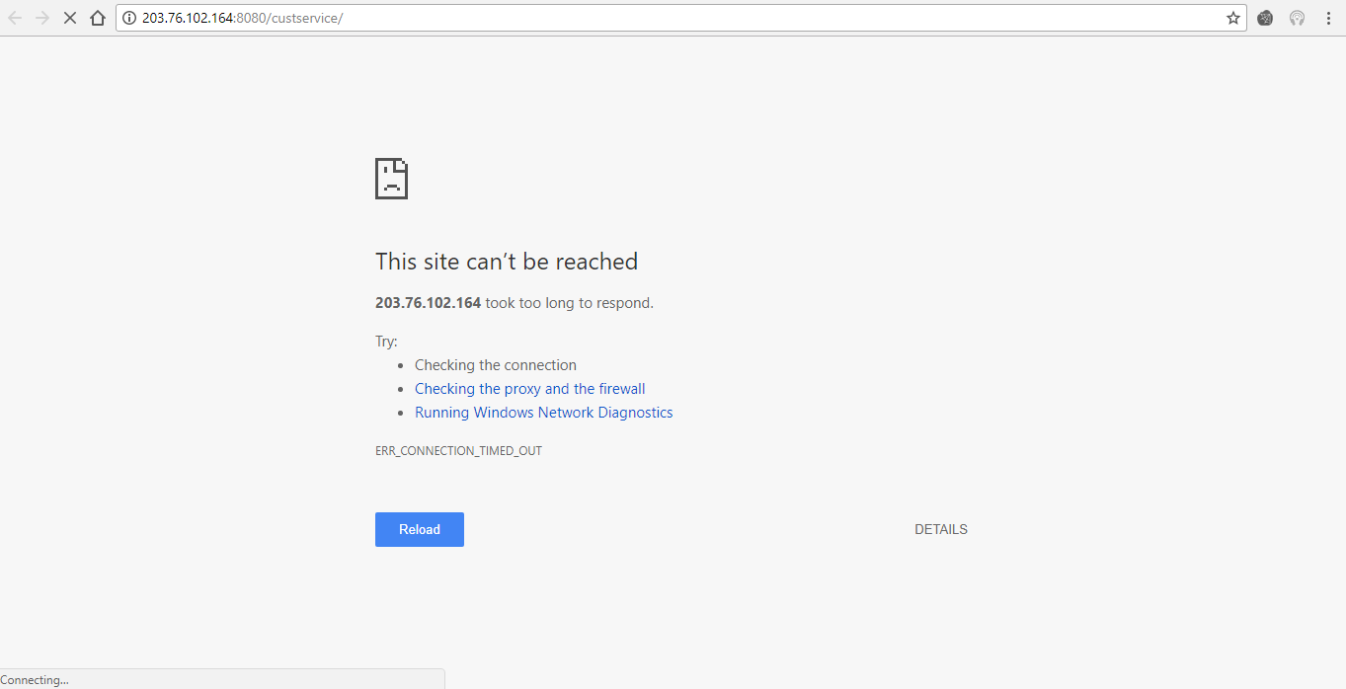

**Screenshot 1**

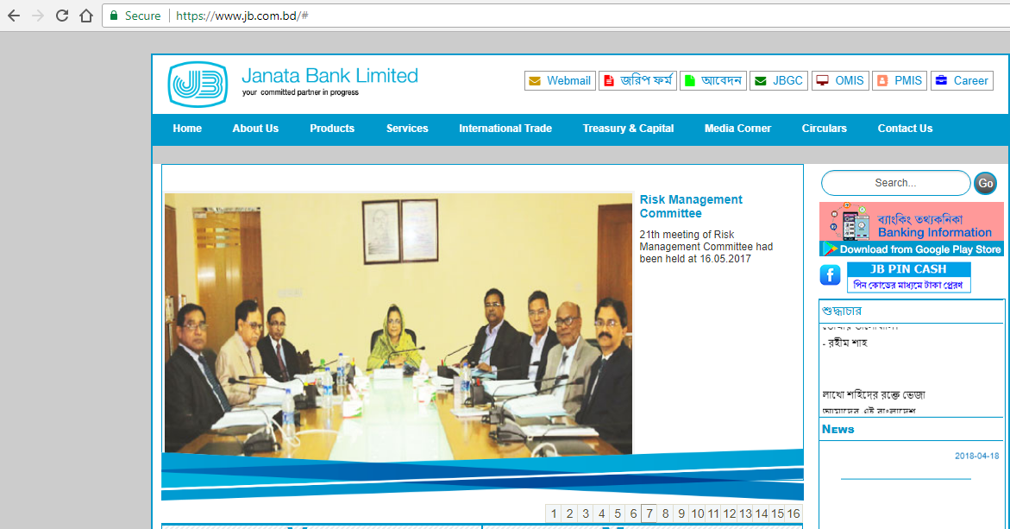

**Screenshot 2**

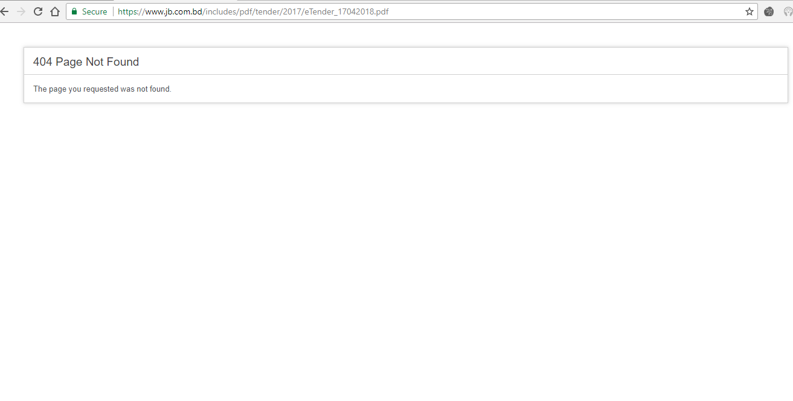

**Screenshot 3**

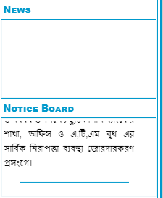

**Screenshot 4**

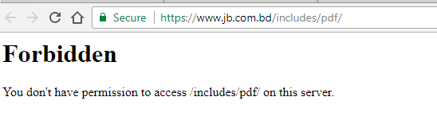

**Screenshot 5**

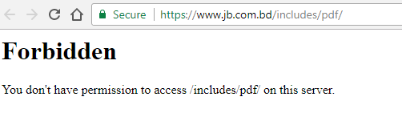

**Screenshot 6**

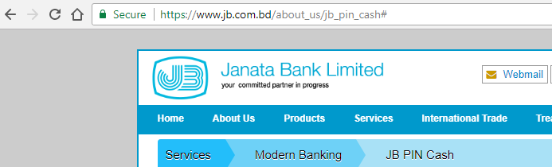

**Screenshot 7**

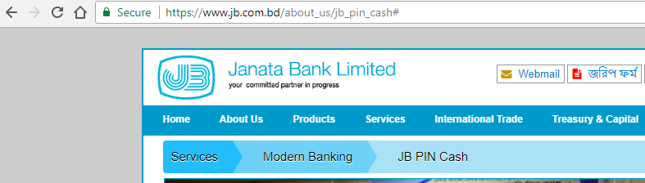

**Screenshot 8**